HUMAN COMPUTER INTERACTION IN KOO KOO RESTAURANT MENU ORDER MANAGEMENT SYSTEM

ALFRED MUTUMA NJUGUNA

A PROPOSAL/ RESEARCH PROJECT SUBMITTED TO THE DEPARTMENT OF INFORMATION TECHNOLOGY IN PARTIAL FULFILMENT OF THE REQUIREMENT FOR THE AWARD OF A DEGREE IN BACHELOR OF SCIENCE INFORMATION TECHNOLOGY AT JOMO KENYATTA UNIVERSITY OF AGRICULTURE AND TECHNOLOGY.

2022

DECLARATION
I declare that this proposal is my original work and has not been presented for award of a degree in any other university.
Signature………………………….. Date………………………….
ALFRED MUTUMA NJUGUNA
SCT221-D1-0102/2017

This proposal has been submitted for examination with my approval as University Supervisors.

Signature……………………………… Date……………………………..
DENNIS NJAGI
LECTURER, JKUAT

ABSTRACT

In the competitive business world we live in today, reducing operational cost and increasing productivity is paramount. Particularly, manpower can be expensive for restaurants. In this situation, an automated restaurant menu order management system can help to increase process efficiency, decrease order processing time and guarantee better Quality‐of‐Experience (QoE) for customers. This BSC I.T. project focuses on developing a menu order management system and evaluating its effects on business process efficiency and customer satisfaction. The menu order management system is here to help communication between all teams within a restaurant by minimizing the probability of human errors. It has three core items: requirements analysis, implementation and evaluation.
As a starting point, a real business setting of a restaurant is identified based on selection criteria. The requirements are elicited from a restaurant and user survey. The user survey is conducted for understanding the users’ preferences on using mobile applications. The system is then designed and developed based on identified requirements, user survey and design principles of client‐server application. The evaluation shows the effects of introduction of the automated system on order processing time and customer satisfaction. The system is developed using waterfall methodology. The results show that average order processing time for drinks and food orders is reduced after the introduction of the automated system. Also, the customer Quality-of-Experience measured by evaluation forms has an above average score. Therefore, it is deduced that the introduction of the automated system reduces the order processing time in the experimental setup.

Contents
DECLARATION ii
ABSTRACT iii
CHAPTER ONE 1
1.1 Background 1
1.2 Introduction 3
1.3 Statement of Problem 4
1.4 Proposed solution ………………………………………………………………………………………………………………………….4
1.5 Objectives 4
1.6 Research Questions/Hypothesis 5
1.8 Justification 5
CHAPTER TWO 8
LITERATURE REVIEW 8
2.1 Introduction 8
2.3 Chapter Summary 11
CHAPTER THREE 13
3.1 Introduction 13
System Development Methodology 15
3.3 Feasibility study 16
3.3.1 Technical feasibility 16
3.3.2 Operational feasibility 17
3.3.3 Economic feasibility 18
3.3.4 Schedule feasibility 19
3.3.5 Legal feasibility 19
3.4 Requirements Elicitation 20
3.7 What the application will do 28
3.8 Interface Design 29
(ii) Customer Order Interface 31
(iv) Order receiving interface 32
(vi) Add user interface 33
3.9 System architecture 33
3.10 Database design 34
4.4 Data flow diagram 35
CHAPTER FOUR 38
SYSTEM CODE GENERATION AND TESTING 38
4.2 System code generation 39
4.3 System Testing 41
4.3.1 Run/Operate the Software 43
4.3.2 Detailed Implementation Plans 44
4.3.3 Changeover 44
Training of Operators and Users 44
4.5 User requirements 46
4.5.1 Functional requirements 46
4.5.2 Non-functional requirements 47
4.6 System requirements 47
4.6.1 Software requirements 47
4.6.2 Hardware requirements 48

CHAPTER ONE

Background
In the modern world that we live in, technology has undeniably become integrated into every aspect of our life. It is therefore highly important to sustain, spread and integrate this technological involvement in our lives due to its countless benefits. Technology in any business is needed to greatly optimize both organizational and managerial aspects of such an organization. There is also provision of real-time information, customizable interfaces based on the requirements, and high adaptability to any business field. Long gone are the days where manual input was used. This was a slow and tedious process and needed to be replaced. Automated systems are more accurate and save on time.
The hospitality market is likely to witness substantial growth in the not so distant future. Technology disruption in the restaurant industry and soaring need for restaurant specific software such as billing and payment processing, inventory management, table management and menu management are among the key trends stimulating market growth. Moreover, growing awareness regarding importance of data analytics solutions in providing valuable insights to improve day to day operation is poised to provide an up thrust to the market. In our local scenario restaurant management is mainly done by noting the customer’s order on paper and forwarding the same to the chef for processing. Online food ordering systems are also used where a customer orders a meal of his or her choice and it’s delivered within a predetermined time frame within a town or a city. In the medium and small enterprise you will rarely find a restaurant with a digital menu order management system.
My case study is Koo koo restaurant a medium size restaurant situated in Nanyuki town that was started in the year 2010. On average kookoo serves about 100 customers in a day. My aim is to design and implement a user friendly and easy on the eyes menu order system. As they say ‘people eat with their eyes’.
At Koo koo restaurant the task of getting an order from a customer is done by word of mouth and sometimes orders are noted down on a paper if particularly a waiter/waitress feels they may forget orders or not capture the orders accurately if many. The customer does some formal conversation like hello, hi, etc. Then he/she demands for today’s menu and does some discussion over menu items then he/she places an orders. It takes 5 to 10 minutes to book the order and the waiter books the order on paper so there is the probability of loss and duplication of customer information. The restaurant menu order management system puts the order in a queue with specific priority according to time and quantity, and then a chef is assigned for the specific order to complete it.

Introduction
Human computer interaction (HCI) is research in the design and the use of computer technology, which focuses on the interfaces between people (users) and computers. HCI researchers observe the ways humans interact with computers and design technologies that allow humans to interact with computers in novel ways.
As a field of research, human computer interaction is situated at the intersection of computer science, behavioral sciences, design, media studies, and several other fields of study. The term was popularized by Stuart K. Card, Allen Newell, and Thomas P. Moran in their 1983 book, The Psychology of Human–Computer Interaction. The first known use was in 1975 by Carlisle. The term is intended to convey that, unlike other tools with specific and limited uses, computers have many uses which often involve an open-ended dialogue between the user and the computer. The notion of dialogue likens human–computer interaction to human-to-human interaction: an analogy that is crucial to theoretical considerations in the field.

In this paper, we are building up a system which is based on Human Computer Interaction to place an order for food in a restaurant. People tend to go to a restaurant where service and convenience of the customer are given top priority. A major problem faced by the customers in a restaurant is waiting for the staff to take the order, this is because during rush hours the availability of staff decreases. This mishap can be removed by implementing a menu ordering system that is web based.
The traditional menu ordering systems are time-consuming and susceptible to human errors which can only be reduced, not completely eliminated. My aim is to develop a cost-effective system which is affordable to medium and small restaurants. This system aims at creating a user-friendly interface, service navigation, low cost, and decreasing the order processing time, reducing the paperwork and the human errors in it. This is a remedy for the traditional system of pen and paper, our system aims at providing the following features:
- Allow the restaurant to operate faster (faster seating, faster order preparation, faster turnaround on food).
- Reduce employee error, thereby increasing customer satisfaction. This also reduces waste as when the wrong item is ordered, the food must be discarded.
- To minimize the flaws in a conventional system by automating the working of a restaurant.

1.3 Statement of Problem
Currently, many restaurants use a paper-based system to communicate between the restaurant, kitchen and billing department which can be shown to be one of the least efficient approaches. This research seeks to solve this problem by designing, implementing and testing a menu order management system that is affordable to small, medium and even large enterprises. The following operations will be performed by the system:-
- A customer makes an order from a menu, every item on the menu has an estimated waiting/processing time.
- Chefs working in the kitchen receive the order, table number is indicated as well.
- Customer’s order is acknowledged, and they can now wait patiently without the need of enquiring about the order every now and then as is the norm in many restaurants in Kenya.
- A receipt for billing purposes is generated.

1.4 Proposed Solution
This research seeks to design and implement such a system that will lead to major advantages:
- During rush hours multiple customer requests will be handled efficiently without the customer having to wait to place the order.
- This system eliminates the overhead of restaurant staff taking orders from the customer and the miscommunications happening in the process

1.5 Objectives
The main objective of this study is to design and implement a computerized Restaurant
Menu order system and the specific objectives are:
1. To analyze the requirement of the proposed system.
2. To design and develop restaurant menu system.
3. To test and implement the restaurant menu system.

1.6 Research Questions/Hypothesis
To fill the knowledge gap on this topic (human computer interaction in koo koo restaurant menu order management system), this study seeks to investigate the following questions.

Q1. What are the views of the customers on computerized restaurant menu system?
Q2. What is the view of the restaurant management on computerized menu system?
Q3. Does the information on the menu, the waiting staff and the innovative technology on
menu displaying devices affect customer satisfaction?

1.7 Hypothesis
The application automates the order taking process at restaurants. The automated order processing time is expected to be less than the manual order processing time. This application should not decrease customer satisfaction as they are served faster than the manual process.

1.8 Justification
This system will increase efficiency and decrease overheads without compromising on customer’s Quality of Experience. Track sales down to each item, generate bills fast and accurately, better customer service, better communication between kitchen, waiting and cashier.

1.9 Proposed Research and System methodologies
Water fall methodology is traditional software development method. The waterfall method is a linear model that consists of sequential phases (requirements, design, implementation, verification, maintenance) focusing on distinct goals. Each phase must be 100% complete before the next phase can start. There’s usually no process for going back to modify the project or direction.
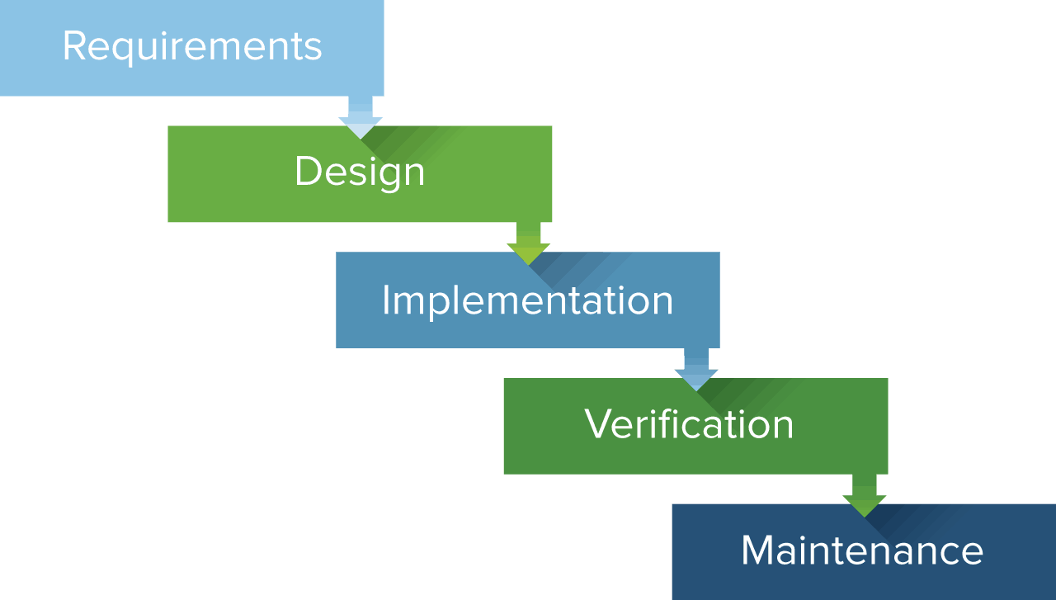

For simple, structured projects, Waterfall is best used because of its linear and easy-to-follow design. Its visual representation makes it easy to understand the steps that must be completed to achieve project objectives.
Some further advantages of Waterfall include:
- Ease of use and manageability:
- High level of discipline
- Comprehensive documentation

1.10 Scope
This study focuses on Koo koo restaurant a medium sized restaurant located in Nanyuki town. It focuses on what the computerized menu system does, the view of the restaurant customers about the menu, the effect of the information provided by the menu, the technology innovation on menu displaying devices and the services of the waiting staffs on customer satisfaction.

CHAPTER TWO

LITERATURE REVIEW

2.1 Introduction
This chapter documents the conceptualization, review of the literature, the empirical review and the summary of the research gap. Materials such as printed textbooks, journals and past copies of research work were gotten from the library and materials such as: ebooks and journals were gotten online.
2.2 Theoretical review/Conceptual Framework
Over the years, technology has greatly revolutionized the service industry. The restaurant industry has been very significantly altered. A great deal of these operations and innovation has been with point-of-sale (POS) operations but we forget that the most important part of the restaurant was still up and ripe for innovation. This is the menu. Restaurant menus have evolved from extremely humble beginnings on carte chalkboards and print with no images to today’s vibrant and colourful displays. There is a famous saying that “People eat with their eyes”.
Restaurants began to offer digitized versions of their menus and almost immediately began to reap the benefits. E-menus provide the customer with a lot more information about menu items than a traditional paper menu. It is proven that customers who sit in restaurants that provide e-menus spend about 10% more in terms of money than those who are seated at restaurants that provide the traditional menus. With vivid visuals, you know exactly what you are going to get served on your plate. Customers also feel more involved with the process as it has been made more interactive and user friendly.
E-menus also greatly advantage the waiters in that use of tablets to take orders eliminate order taking errors. There is now less confusion in the kitchen as everything is automated and clearly distinguished. Through integration of e-menus and tablets, expenses that would regularly be incurred on stationery is eliminated and the waiters have an easier time piling up orders through easy-to-use interfaces. Through this revolution, restaurants slowly build their e-reputation and become relevant in the technological world.
With electronic menus, orders can be taken correctly the first time. There is no need to run back and forth to a distant terminal, because the terminal is always with the server. The exception, of course, comes in terms of battery percentage of the terminal. Every order is associated with an individual seat at the table, and orders are built one customer at a time, just like on paper, but with greater precision and accuracy. Items can also easily be shared by the whole table, moved or customized, and the cost calculated in real time.

2.2.1 Point of Sale Systems
Point of sale system which is also known as POS system, is a combination of hardware and software that allows the staff to perform some tasks. There are a lot of businesses using this system to operate their daily transactions including restaurants, hospitals and hotels.
POS system includes few hardware such as display pole, printer, handheld device, terminal and cash register. Display pole is used to show the price of the item when the item is scanned. Printer is used to print the receipt after the customers make their payment. Handheld device is used to accept the credit card payments from the customers. Terminal is the main screen that use to fill in the transaction details. Cash register is used to keep the cash. When the staff receive the cash from the customers, they keep the money inside the cash register (“Software Testing Help”, 2018).
When the customers go into the restaurant, they either make their order first at the counter or wait to be served by the waiter. If the restaurant requires the customers to order first, they need to queue up at the counter and make their order. Then, they only find their seats in the restaurant. The other way is the customers find their seat when they reach the restaurant. The waiter will serve the customers and help them to make the order.
A restaurant might have more than one POS terminals. All terminals of the restaurant are connected to a file server. The configurations and settings are done on the server, then send back to the terminals. If the restaurant accepts credit card for the payment, third party provider is involved to perform the credit card processing. The data will send to the bank or third party when the staff perform credit card transaction.
The strength of this system is it can reduce the time of taking order. This also can improve the satisfaction of the customers. By using this system, the duration of taking order is fast. It also can reduce the mistakes that will done by the staff. It allows the staff to track the sales of the restaurant. The staff is allowed to generate daily and monthly sales report through this system. The staff also can view the history of all orders.
Limitation of this system is the customers are tired of waiting on the queue. During the peak hours such as lunch time and dinner time, there are a lot of customers in in the restaurant. The customers need to wait for a long time to wait for their turn. Some of the customers might lose their patience and walk out from the restaurant.

2.2.2 Online Ordering Systems
It is almost impossible to imagine a world without food delivery. This service has become so embedded into our lives that it seems like a basic right. There are several platforms that deliver meals, foodstuffs and groceries to your doorstep, for example UberEats, Jumia Food, Yum deliveries and Glovo among others. Such platforms often require the user to create an account or log in with Facebook. This ensures that the user does not have to keep on filling in user details such as location. This requirement also enables the building of user history hence enabling the user to keep on reordering the same item(s) if that is their desire.
The Recommendation algorithm suggests meals to the customers based on previous orders. It makes it easier for the customer to build his/her order and also view the most popular dishes. Moreover, various dimension filters can be used according to individual preferences e.g. Price, taste or quantity. The client is able to browse through the selection of menu items available without leaving the comfort of wherever they are. They are then allowed to mix and match items, add and remove items and in some, but very few cases, order from more than one restaurant at a time.
Once selected, these items are added to a cart that is often represented by a trolley symbol. Once the user is satisfied with their selections, they proceed to check out. The client is often presented with more than one payment option for example Debit card, Credit card, cash on delivery or MPESA where this option is applicable. The items are then delivered to the user’s location of convenience. There is, however, the option of individually picking the order up. In this case, the user would have managed to avoid long queues and only leave to collect their order when it is ready. The use of technology ensures that the customer’s order is accurate hence leaving no room for disappointment.
The limitation of this system is that not all the people have internet access or are literate. Some of the senior citizen do not know how to use the internet. Therefore, they are unable to access this service. If there is internet connectivity issues or internet down times people will be greatly inconvenienced.
The similarity of this system and proposed system is both of this systems using internet to let the customers place order. The difference of both of this system is online ordering system is used to make an order when not in a restaurant. However, proposed system is used when the customers make their order themselves in a restaurant.

2.3 Chapter Summary
The restaurant management system will firstly benefit both the customer and the establishment or business. With an easy to use app, customers can easily browse through menu options, customize dishes and thereafter place orders as opposed to standing in line, only to read the menu at the counter and then proceed to order. A lot of time will be saved and there will be a subsequent decrease in human traffic at these establishments. This will help to reduce crowds hence adhering to the COVID-19 regulations.
From the restaurant’s point of view, they no longer have to spend time manually taking the customers and can now evade communication errors that occur due to miscommunication. With the wake of a global pandemic, the restaurant will now be better prepared to deal with customers due to the ability to reserve a table. They will get the reservation beforehand and be able to ensure social distancing depending on the number of people expected. This is in line with government and global directives.
Billing and payment is made easier and contact-free thus protecting both the customers and staff members. In these times, anything that can be implemented to prevent direct human contact should be enforced due to the ease at which the coronavirus is spread. In terms of payment, cashless payment is secure and transparent. It is easy for both the customer and business to trace payments in case of any dispute

2.4 Research gaps
Most of the studies carryout on electronic/digital menus in restaurant industry still have
some lapses that require more vigorous research.
More also, some of the studies do not actually make use of full scale restaurant as their case studies but rather they make do with a small scale restaurant for example ones found within universities campuses and this have limited the generalization of their findings. Some of the previous studies carryout on this topic have not actually subject the computerized restaurant menu to usability test which has hinder them from gathering more data, exploring the interface limitation and to get feedback and suggestion for revision.

CHAPTER THREE

3.1 Introduction
This section documents the analysis and design of the system to be implemented. It provides the general structure of how the researcher goes about to answer the research questions. It also documents the research strategies.
3.2 System Development Methodology
A methodology is a system of methods used in a particular area of study. It is practices, procedures and rules used by those who work in a discipline or engage in an enquiry. It is in other words, a set of working methods.

Methodology involves a process whereby the existing or current system is studied to identify the information requirements. It is used to refer to a specific series of steps or procedures which governs the analysis and design of a particular project. It also includes the techniques and methods which are used to collect and analyze information. The types of methodologies includes: Prototyping, Object Oriented Analysis and Design Methodology (OOADM), and Structured System Analysis and Design Methodology (SSADM).

Prototyping: A prototype typically implements only a small subset of the features of the eventual project (Osuagwu 2008).

Structured Systems Analysis and Design Methods (SSADM): Structured Systems Analysis and Design Methodology (SSADM) is an integrated set of standards which guides the analysis and design of computer systems.

Object-Oriented Analysis and Design Methodology (OOADM): OOADM is adapted from Michael Gora’s application of OOADM in Data Base Management System (DBMS) application. It can be used to analyze problem requirements, design a solution to the problem, and implement a solution in a programming language or database.
This methodology uses object-oriented perspective rather than a functional perspective as in the SSAD methodology. An object is a person, place or thing initially drawn from the problem domain which has three aspects to it: what it knows its identity and certain attributes, who it knows as relationships to other objects and what it does (its methods it is responsible for performing on its data).

Object-oriented analysis is the process of developing an object-oriented model of the problem domain where the initial objects represent the entities and methods related to the problem that needs to be resolved. These identified objects represent entities, and possess relationships and methods that are necessary for the problem to be resolved.

User centered design
The best way of ensuring that the system is usable is to follow a user centered design process, where users are considered and involved in the process and usability testing is carried out at many stages of the design process. A good understanding of needs and regular involvement of users means that usability issues are identified early enough to fix them.

User centered design is a process or set of techniques that can be used to create a usable system. User centered activities can be included throughout the design and development process.
User centered design is not a step by step magic methodology. It is closer to a philosophy or way of looking at the world. It is about genuinely wanting to create something that can be used by the real audience. The researcher intends to use this design.

Object-oriented design is the process of developing an object-oriented model of the system necessary to meet the specified requirements.
The object-oriented approach to system development views a system as a collection of interacting objects that work together to accomplish tasks.
Object-oriented development can follow an iterative and incremental lifecycle.

The four phases of the object-oriented lifecycle are inception, elaboration, construction, and transition.

Inception phase
This phase was used to establish the business case for the system and delimit the project scope. To accomplish this, I identified all external entities with which the system will interact (actors) and define the nature of this interaction at a high-level. This involves identifying all use cases and describing a few significant ones.

Elaboration phase
This phase was used to analyze the problem domain, establish a sound architectural foundation, develop the project plan and eliminate the highest risk elements of the project. Architectural decisions were made with an understanding of the whole system; its scope, major functionality and nonfunctional requirements such as performance requirements. Also an executable architecture prototype was built in one or more iterations, depending on the scope, size and risk of the project.

Construction phase
In this phase, all the remaining components and application features will be developed and integrated into the product and all features thoroughly tested.

Transition phase
This phase will transition the software product to the user client. This phase provides training of users and roll-out the product to the marketing, distribution and sales teams.

System Development Methodology
Water fall model also refer to as the linear-sequential life cycle model. It’s very simple to understand to use. That is major reason why this system is been done using this method. In water fall model, each phase must be fully completed before the next phase can begin.
This methodology, is basically used for the project which is small and there is no uncertain requirement. This feature, make the water fall model to be the right model to be apply in this project work. At the end of each phase, a review is implemented to see if the project is on the track and also to determine whether to continue with development. In this model testing of the system can only come after the development is completed. Phases development in waterfall model do not overlap.
It is said that the Waterfall methodology follows the adage to “measure twice, cut once.” The success of the Waterfall method depends on the amount and quality of the work done on the front end, documenting everything in advance, including the user interface, user stories, and all the features’ variations and outcomes. With the majority of the research done upfront, estimates of the time needed for each requirement are more accurate, and this can provide a more predictable release date.

3.3 Feasibility study
This is an evaluation and analysis of the potential of the proposed project which is based on extensive investigation and research to support the process of decision making. It assesses the operational, technical and economic merits of the proposed project. The feasibility study is intended to be a preliminary review of the facts to see if it is worthy of proceeding to the analysis phase. From the systems analyst perspective, the feasibility analysis is the primary tool for recommending whether to proceed to the next phase or to discontinue the project.

3.3.1 Technical feasibility
This assessment is focused on gaining an understanding of the present technical resources of the organization and their applicability to the expected needs of the proposed system. It is an evaluation of the hardware and software and how it meets the needs of the proposed system. The systems project is considered technically feasible if the internal technical capability is sufficient to support the project requirements. The essential questions that help in testing the technical feasibility of a system include the following:
- Is the project feasible within the limits of current technology?
- Does the technology exist at all?
- Is it available within given resource constraints?
- Is it a practical proposition?
- Is there enough manpower- programmers, testers & debuggers?
- Do the required software and hardware exist?
- Are the current technical resources sufficient for the new system?
- Can they be upgraded to provide the level of technology necessary for the new system?
- Do we possess the necessary technical expertise, and is the schedule reasonable?
- Can the technology be easily applied to current problems?
- Does the technology have the capacity to handle the solution?
- Do we currently possess the necessary technology?
On technological feasibility aspect this project was deemed feasible based on the following reasons:
- The current technology both hardware and software technologies available are sufficient to support this project. The system will use a modest amount of a computer’s processing power.
- The required expertise or human resource required to see this project come to fruition is readily available in Kenya.
- The computerized restaurant menu system discussed here has the capacity to solve the problem of traditional restaurant menu system. This system provides for customer food order placement which is relayed to kitchen staff and then to cashier for billing. It will enhance the dining experience and make the whole process seamless.

3.3.2 Operational feasibility
Operational feasibility is the measure of how well the project will support the customer and the service provider during the operational phase. It is dependent on human resources available for the project and involves projecting whether the system will be used if it is developed and implemented. The essential questions that help in testing the operational feasibility of a system include the following:
- Is the project feasible to operate or not?
- Does current mode of operation provide adequate throughput and response time?
- Could there be a reduction in cost and or an increase in benefits?
- Does current mode of operation offer effective controls to protect against fraud and to guarantee accuracy and security of data and information?
- Does current mode of operation make maximum use of available resources, including people, time, and flow of forms?
- Are the current work practices and procedures adequate to support the new system?
- If the system is developed, will it be used?
- Does it agree with the government regulations
- Will the proposed system really benefit the organization?
- Will the system affect the customers in considerable way?
- How do the end-users feel about their role in the new system?
- How will the working environment of the end-user change?

Operational feasibility aspect of this project was deemed feasible based on the following reasons:
- This system does not only enhance the customer’s quality of service but will reduce the number of waiters required and thus reduce operational costs. The waiters will only help customers where necessary and deliver ordered food.
- There will be almost no food mix up or other errors because no one will be required to memorize customer orders this will prove effective especially in a busy restaurant.

3.3.3 Economic feasibility
This assessment aims to determine the positive economic benefits to the organization that the proposed system will provide. It typically involves a cost/ benefits analysis and it’s the most frequently used method for evaluating the effectiveness of a new proposed system. Possible questions raised in economic analysis are:
- Is the system cost effective?
- Do benefits outweigh costs?
- The cost of doing full system study
- The cost of business employee time
- Estimated cost of hardware
- Estimated cost of software/software development
- Is the project possible, given the resource constraints?
- What are the savings that will result from the system?
- Cost of employees' time for study
- Cost of packaged software/software development
- Selection among alternative financing arrangements (rent/lease/purchase)

Economic feasibility aspect of this project was deemed feasible based on the following reasons:
While the initial cost of rolling this computerized menu system may be a bit costly in the long term the benefits will outweigh the initial cost plus operational cost. The number of waiter required in a restaurant with this system will be fewer compared to a restaurant using the traditional system.

3.3.4 Schedule feasibility
It is the measure of how reasonable the project time table is or the deadline is reasonable or not. During the lack of time or the time become mandatory, we must finish the project within a given time period.
With the right expert(s) this project can be completed in a reasonable amount of time given that it is not very complex.

3.3.5 Legal feasibility
The proposed system shall conform to laws and regulations set by both the Koo koo restaurant and the government of Kenya. The system will meet the legal requirements of this nation and meet standards of IT projects and computer systems set by international bodies like ISO.
This project is being done by professionals and it does not infringe on any copyright, it does not contravene any law of the Republic of Kenya in any way.

3.4 Requirements Elicitation
Research Design
In order to investigate the research questions proposed by this study, the qualitative method was undertaken. This method was chosen because it is based on inductive reasoning and it enables the researcher to make use of case study to analyze and understand the requirement of the computerized restaurant menu and what is effect of the information on menu, waiting staff, and innovative technology on customer satisfaction.
3.4.1 Population of the Study
The population of this study, is the entire customer of Aroma restaurant Bauchi and the manager of the restaurant.
3.4.2 Sampling Technique and Sample Size
Sampling technique, detailed the method used in picking, representative sample from the general population of the study and the sample size is the subject chosen to represent the characteristic whole population.
3.4.3 Sampling technique.
The convenience sampling techniques was used in this research. The respondent was chosen base on their proximity, accessibility and availability. That is to say the customers present at the time of data collection were pick as the respondent.
3.4.4 Sample Size.
The sample size of this study were the customers that visited the restaurant on the 6th of April 2022 and the manager of the restaurant. Sixty nine (69) customer accepted to participate. Therefore, the sample size was 69.

3.4.5 Data Collection Technique
This describes the method which the researcher employ in gathering/collecting the data necessary in carrying out this research work. Observation and dichotomous questionnaire was employed in this research.

3.4.6 Questionnaire
The questionnaire entails yes or no questions that were answer by the customers of the restaurant to help in ascertaining the requirement of the computerized restaurant menu and to also investigate the effect of the information provided by the menu, waiting staff and innovative technologies in menu displaying devices on customer satisfaction.

3.4.7 Instrument Design
The questionnaire was adapted from the work of Kulmanali Khilare on the digital menu relevance for café in India with special reference to café coffee day. The questionnaire is a dichotomous questionnaire which is made up of 18 questions divided into four section. Section A: contain three questions and is targeted at the demographic factor, section B contains six questions and it focuses on customer’s views, lastly section C contains three questions and is targeted at investigating the effect of the information presented by the menu, waiting staff and innovative technology, on customer satisfaction.

3.4.8 Data Presentation
This section present the data collected through the questionnaire.
Table 3.1 Administration and return of questionnaire

Questionnaire | Total | Percentage (%)
Administered | 69 | 100
Returned | 62 | 90
Not returned | 7 | 10
Total | 69 | 100
From the table above, a total number of 69 questionnaires was given out, 62 was returned and 7 was not returned.

Table 3.2: Frequency distributions of respondents according to gender

Option | Respondents | Percentage (%)
Male | 39 | 63
Female | 23 | 37
Total | 62 | 100
From the table above, 63% of the respondents are male while 37% are female.

Table 3.3: Frequency distributions of respondents according to age group

Age Group | Respondents | Percentage (%)
18 – 30 years | 35 | 57
31 – 45 years | 19 | 30
Above 45 years | 8 | 13
Total | 62 | 100

From the table above, 57% of the respondents are between the age bracket of 18 -30 years, 30% are between the age bracket of 31 – 45 while 13% are above 45 years old.

Table 3.4: Frequency distributions of respondents according to educational level
Educational Level | Respondents | Percentage (%)
Secondary School | 7 | 11
Under-graduate | 45 | 73
Post-graduate | 10 | 16
Other | 0 | 0
Total | 62 | 100

From the returned questionnaires, 11% are of secondary school educational level, 73% are of the first degree level, 16% are of the postgraduate level while 0% falls under the Oder’s category.

Table 3.5: Customers view on computerized restaurant menu

Items | No.  Of  YES | No.  Of  YES | %  Of  YES | %  Of  YES | Total | % Total
Are you aware of computerized  restaurant menu? | 13 | 49 | 21 | 79 | 62 | 100
Have you seen such menu before? | 7 | 55 | 11 | 89 | 62 | 100
would you prefer image in the menu? | 59 | 3 | 95 | 5 | 62 | 100
Would you like to read detail  information about the food? | 44 | 18 | 71 | 29 | 62 | 100
Would you prefer English as the menu  language? | 35 | 27 | 56 | 44 | 62 | 100
Would you prefer Swahili as the menu  Language | 27 | 35 | 44 | 56 | 62 | 100
Would you prefer having nutritional  details on the menu? | 43 | 19 | 69 | 31 | 62 | 100

From the above table, 84% respondent believe that the information provided by the computerized menu, improves their confidence in food ordering process, 69% of the respondents believe that the services of the waiting staff is highly significant in the restaurant services and lastly 94% of the respondent agree that innovative technology like the tablet eases the food ordering procedures.

3.5 Data and System Analysis:
Analysis of data is a process of inspecting, cleaning, transforming, and modeling data with the goal of discovering useful information, suggesting conclusions, and supporting decision-making.
After the completion of data gathering step, the collected data about the system is analyzed to ensure that the data is accurate and complete. Data flow diagram and system flowchart are common tools use for the data analysis. Therefore, the researcher has opted to use system flowchart. System flowchart, explain the workable system using diagram to show the flow of data through the system. It is used in analyzing, designing, documenting and managing the system to solve the problem. This system required two flow chart. They are as follows
- Client side system flowchart.
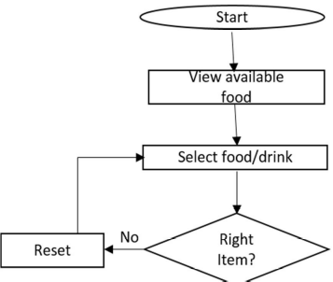
Confirm items
Connect to server
Send
stop

The client starts the system, client view the available food and select food, drink or either both and check if the right item has been selected. If no the client reset and go back to the selection stage again but if it is yes, the client proceeds to the next stage which is the confirmation. After the confirmation stage the client connect to the server and after this stage the client can now send the order to the waiter that is already waiting using the server application.
The Server Side System Flowchart.
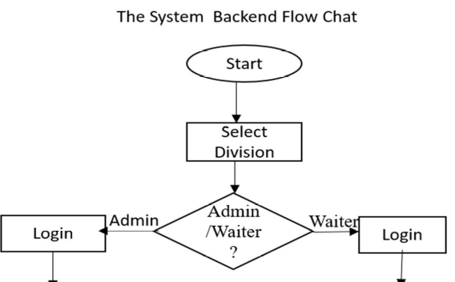
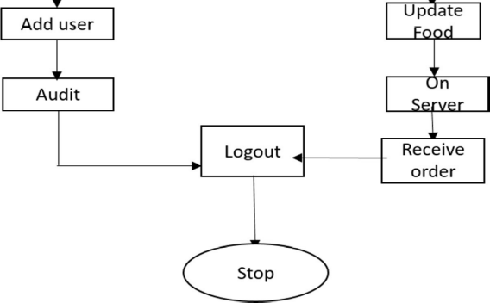
The user starts the system, then select division if the division selected is manager, then the user login as the manager and after login in, the manager manages users(add new waiter, remove unwanted waiter and updating waiter’s credentials) after this stage the manager audit the system and finally logout but if the division selected is waiter’ the waiter login and after login in, the waiter manages the food (updating, inserting and deleting) and after this stage, the waiter start the server and await the connection of clients and receive their request and finally logout.

3.6 System specification

Hardware/ Software Interface
These are the hardware and software requirements needed to run the system efficiently. The hardware interface comprises includes of:

• Dual Core(Processor).
• GB Ram
• 512 KB Cache Memory
• Hard disk 10 GB
• Microsoft Compatible 101 or more Key Board
• Web Browser: Internet Explorer 10 or above, Mozilla Firefox or Google Chrome

Implementation Languages
For my restaurant menu order management system I used HTML, CSS, PHP and SQL.

3.7 What the application will do
In this project the menu order management system is web based. Where there is an admin, whose responsibility will include providing username and password to the restaurant employees, system maintenance and administration. Once waiter/waitresses are logged into the system they can start doing their job ie; inserting the food items with actual price as well as processing time for various orders which is quite important.
Customers can then interact with the system without or with minimal help from servers. They can place orders, quantities as well as view the waiting time because we want to be big on efficiency.
Customer data can be tracked to improve on services, customer experience as well as loyalty program.
This system will be completely web based and will be developed using PHP. We will have one home page where multiple options allow the user to choose different food items with the actual price. There will be a system administrator who will have the right to add and manage user accounts, a manager who will be managing product and orders.
System Specification
- Create an account.
- Manage their account.
- Log in to the system.
- Navigate the restaurant’s menu.
- Select an item from the menu.
- Add an item to their current order.
- Kitchen receives order
- Kitchen acknowledges receipts of order
- Review their current order.
- Provide payment details..
- Receive confirmation.

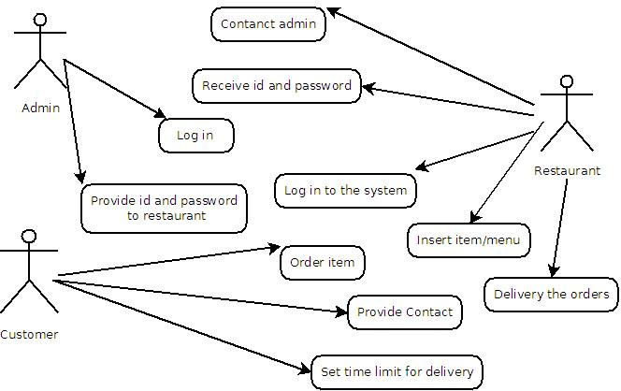
Fig:-use case diagram

3.8 Interface Design
Interface design is concerned with the dialogue between a user and the computer (Human computer interaction). It is concerned with everything from starting the system or login into the system to the eventually presentation of desired inputs and outputs. The system user should always be aware of what to do next. The screen should be formatted so that various types of information, instructions and messages always appear in the same general display area.

Below are the interfaces required for this design,
- Login interface
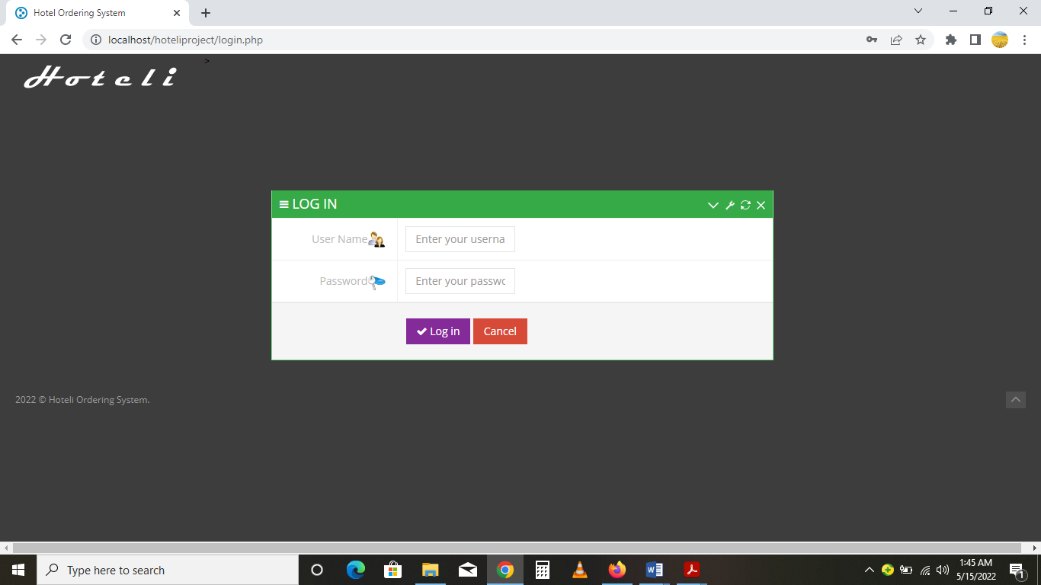

Customer Order Interface
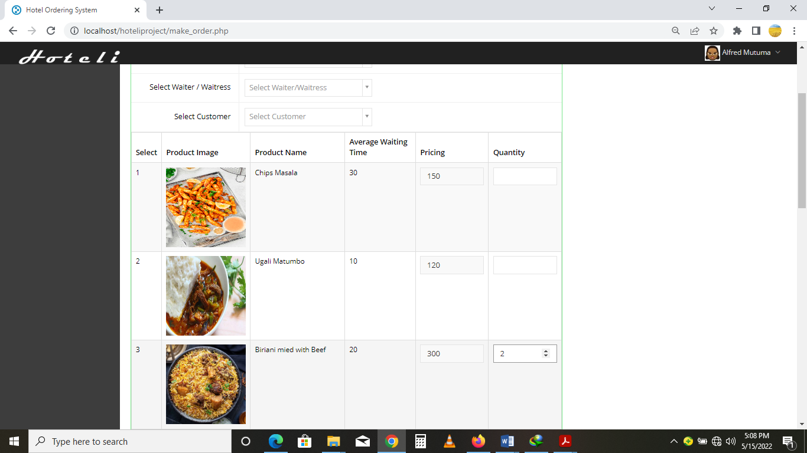

- Upon successful order placement
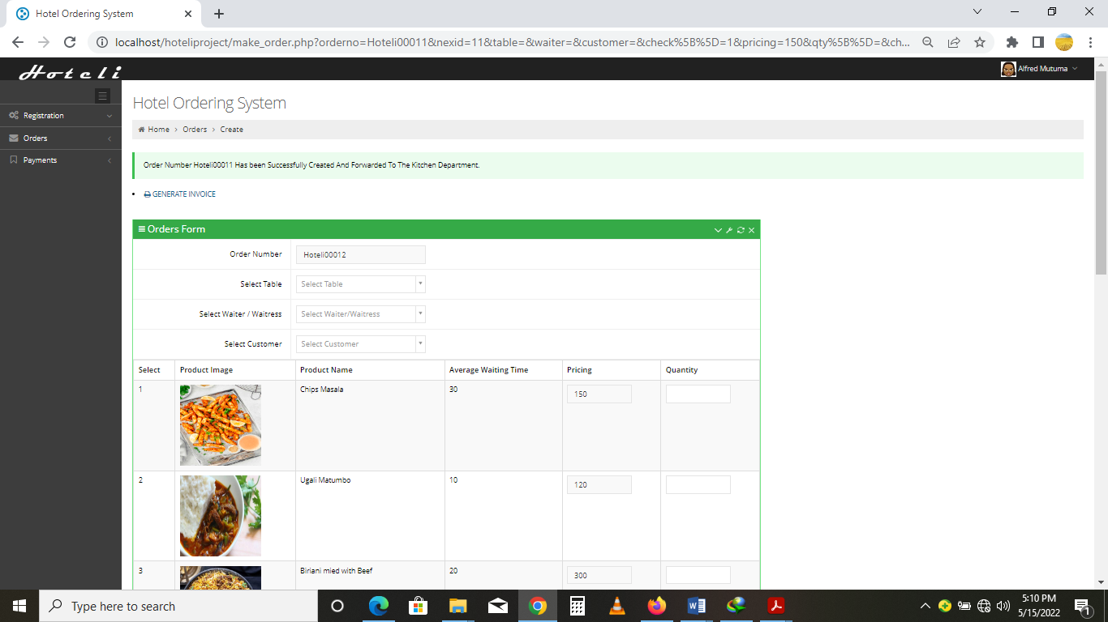

Order receiving interface
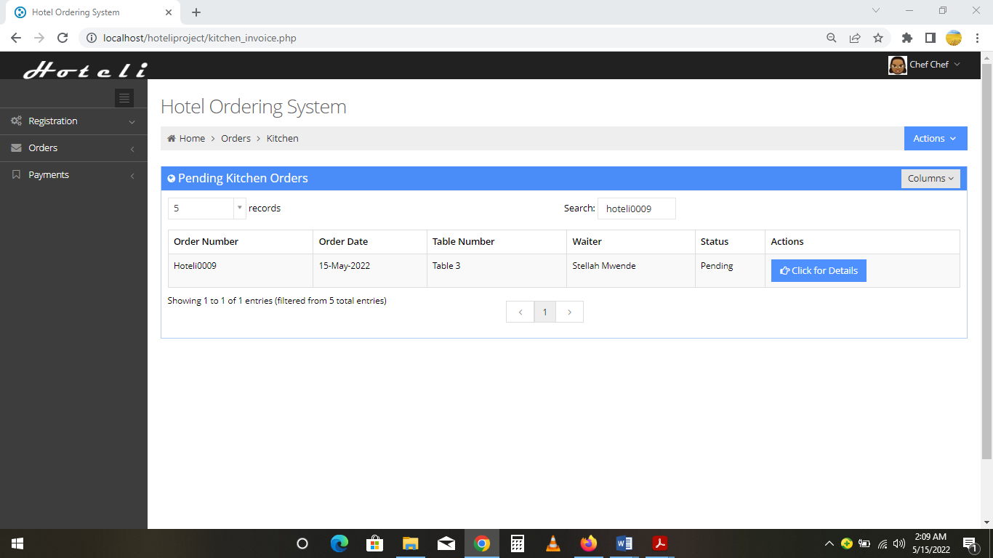
- Add menu product interface
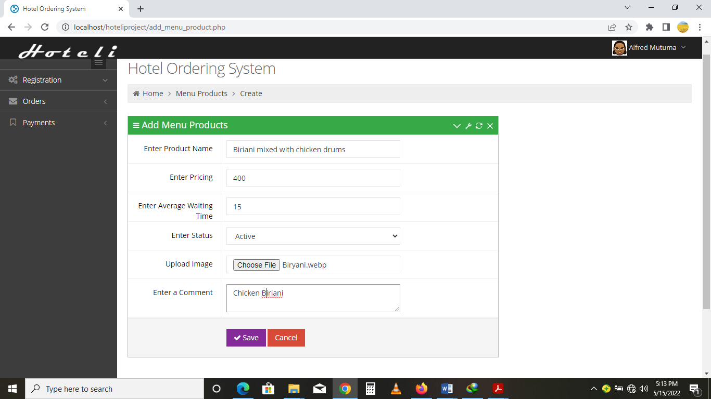

Add user interface
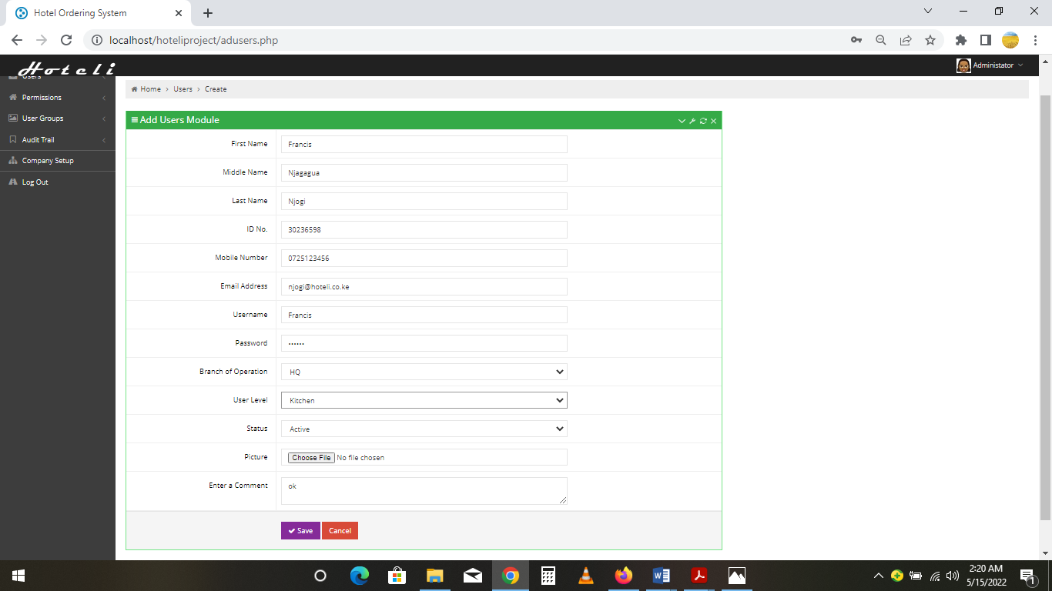

3.9 System architecture
Layered Architecture of Ordering system.
 Customer

Presentation Layer
HTML,CSS, JAVASRIPT
MySQL Database
M
Business Layer
PHP
Tablet App
Data Acess Layer
Data acess layer (DAL) Tomcat Server

Web server

3.10 Database design
Below is an entity relationship diagram

HAS
User_address
User_email
User_mobile
User_nameme
#User_id
#login_id
Login_role_id
Login_username
User_password
Role_id
Role_name
Role_desc.
Per_name
Per_role
Manage
Food_customer_id
food_id
food_name
Food_order
food_price
bill_id
bill_desc
Pay_date
Pay_desc
pay_id
Pay_amount
USER
ROLES
login
Permissions

bill
foods
payments

4.4 Data flow diagram
It is a two-dimensional diagram that explains how data is processed and transferred in a system. The graphical depiction identifies each source of data and how it interacts with other data sources to reach a common output.
Administrator module

Functionalities provided:

- Create usernames and passwords
- View/ edit / delete user accounts
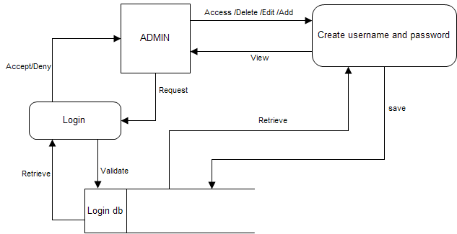

- Customer module

- Functionalities provided:
- View product’s list
- Register
- Place orders

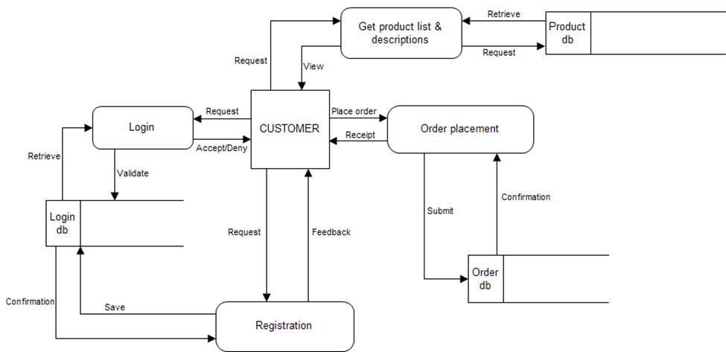

Manager module
Functionalities provided:
- Create product categories and functionalities
- Edit / delete product categories and descriptions
- View and manage orders and sales report
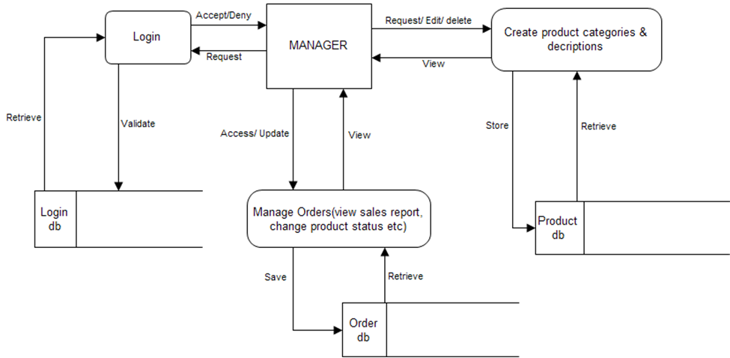

CHAPTER FOUR

SYSTEM CODE GENERATION AND TESTING
4.1Introduction

Implementation

The coding for this system is done using programming languages which include, JavaScript, PHP, Sql, CSS, html and MySQL. The system has a front-end and back-end which is only accessible to an administrator. The backend pulls data from the database and displays it to the administrator via localhost/phpmyadmin. The implementation and testing for this project is using Xampp control panel and Google Chrome browser.

    - Hardware/ Software Interface

These are the hardware and software requirements needed to run the system efficiently. The hardware interface comprises includes of:

• Dual Core (Processor).
• GB Ram
• 512 KB Cache Memory
• Hard disk 10 GB
• Microsoft Compatible 101 or more Key Board
• Web Browser: Internet Explorer 10 or above, Mozilla Firefox or Google Chrome
• Drivers: Java Runtime Environment
• Integrated Development Environment: Net beans.

    - Implementation Languages

For my restaurant management system I used HTML, CSS, JAVASCRIPT, PHP and SQL. Find below, the reasons why I chose these languages:
Hypertext Markup Language, or HTML, is a programming language that describes how information is structured on a web page. Together with CSS, and JavaScript, they make up essential building blocks of websites. Basically, HTML provides the bone structure of a web page, while CSS provides the skin, and JavaScript provides the brain.
HTML provides a means to create structured documents by denoting structural semantics for text such as headings, paragraphs, lists, links, quotes and other items. To depict a HTML element, once must use tags which are basically the less than and greater than signs <> i.e. <img> <p> </p>. HTML provides a means to create structured documents by denoting structural semantics for text such as headings, paragraphs, lists, links, quotes and other items.

PHP (Hypertext Pre-Processor) is a server-side web programing language that is widely used for web development. PHP is widely used for web development because PHP language has its roots in C and C++. PHP is free and has no licensing hence is generally not costly. It works well with MySQL which is a popular database language. Due to its readily available documentation, the language is quite easy to learn hence influenced my decision to pick it.

4.2 System code generation
Kitchen Invoice interface
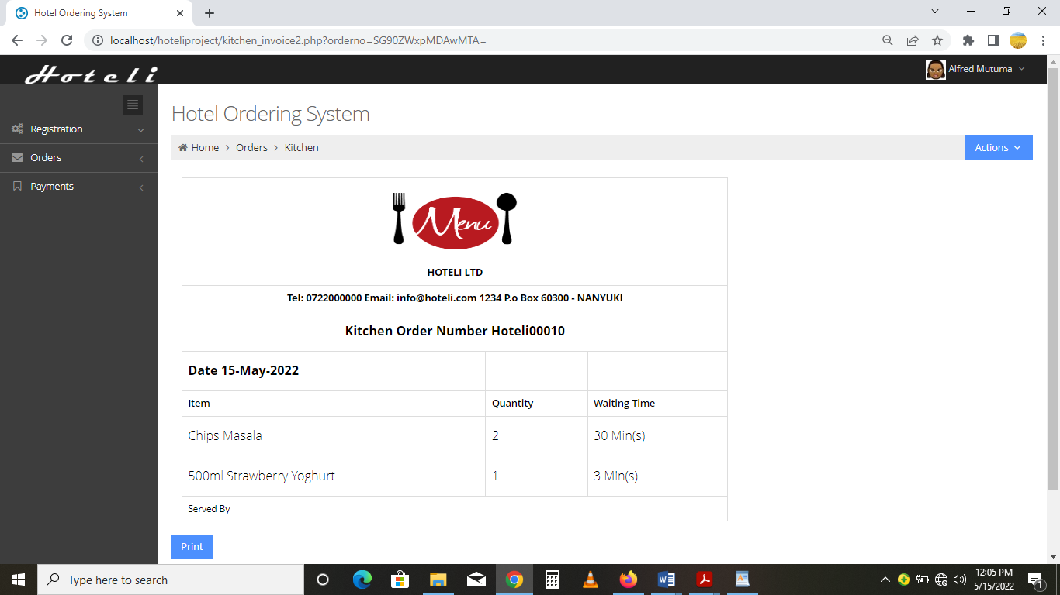

Code snippet for generating a kitchen invoice
<?php
include_once './classes.php';
$newuser = new User();
$users = new Users();
$permission = "T3JkZXJz";
login_required();
?>

<!DOCTYPE html>
<!--
Template Name: Metronic - Responsive Admin Dashboard Template build with Twitter Bootstrap 3.0
Version: 1.5.2
Author: KeenThemes
Website: http://www.keenthemes.com/
Purchase: http://themeforest.net/item/metronic-responsive-admin-dashboard-template/4021469?ref=keenthemes
-->
<!--[if IE 8]> <html lang="en" class="ie8 no-js"> <![endif]-->
<!--[if IE 9]> <html lang="en" class="ie9 no-js"> <![endif]-->
<!--[if !IE]><!--> <html lang="en" class="no-js"> <!--<![endif]-->
<link rel="stylesheet" type="text/css" href="assets/plugins/bootstrap-timepicker/compiled/timepicker.css" />
<span class="username"><?php echo $users->checkuserlogin($_SESSION['user']); ?></span>
<i class="icon-angle-down"></i>
</a>
<ul class="dropdown-menu">
<li><a href="javascript:;" id="trigger_fullscreen"><i class="icon-move"></i> Full Screen</a>
</li>
<li><a href="logout.php"><i class="icon-key"></i> Log Out</a>
</li>
</ul>
</li>
<!-- END USER LOGIN DROPDOWN -->
</ul>
<!-- END TOP NAVIGATION MENU -->
</div>
<!-- END TOP NAVIGATION BAR -->
</div>
<!-- END HEADER -->
<div class="clearfix"></div>
<!-- BEGIN CONTAINER -->
<div class="page-container">
<!-- BEGIN SIDEBAR -->
<?php sidemenu(); ?>
<!-- END SIDEBAR -->
<!-- BEGIN PAGE -->
<div class="page-content">
<!-- BEGIN SAMPLE PORTLET CONFIGURATION MODAL FORM-->
<div class="modal fade" id="portlet-config" role="dialog" aria-labelledby="myModalLabel" aria-hidden="true">
<div class="modal-dialog">
<div class="modal-content">
<div class="modal-header">
<button type="button" class="close" data-dismiss="modal" aria-hidden="true"></button>
<h4 class="modal-title">Modal title</h4>
</div>
<div class="modal-body">
Widget settings form goes here
</div>
<div class="modal-footer">
<button type="button" class="btn blue">Save changes</button>
<button type="button" class="btn default" data-dismiss="modal">Close</button>
</div>
tables/DT_bootstrap.js"></script>
<!-- END PAGE LEVEL PLUGINS -->
<!-- BEGIN PAGE LEVEL SCRIPTS -->
<script src="assets/scripts/app.js"></script>
<script src="assets/scripts/table-advanced.js"></script>
<script>
jQuery(document).ready(function() {
App.init();
TableAdvanced.init();
});
</script>

<!-- END GOOGLE RECAPTCHA -->

<!-- END JAVASCRIPTS -->
</body>
<!-- END BODY -->
</html>

4.3 System Testing
This is the phase in which thorough testing was done on the system to make sure that it was as expected and I achieved this through two main types of testing which include;

- Black box testing.
- White box testing.

Black box testing: - this is the type of software testing that test the functionality of an application without testing its internal structure, this method of testing is applied to every level of software testing.

White box testing: -this involves testing the internal functionality of the system and workings of an application.

In this case the following levels of software testing process were performed under black and white box testing;

- Unit testing- this test was performed to ascertain that different system modules perform the expected tasks as required, the following table shows various units which were tested.

Unit tested | Expected outcome | Actual result expected
Generating a customer’s bill | The system should process and generate customer bills. | To generate customer bills.
Administrator login the system | Only administrator can access administration control panel. | Administrator to login successfully
Inserting new and updating menu items | System should accept the creation and update of food items, processing time and price on the menu. | Creation and update of food items on menu was successful

- Integration testing: - since the system was developed using different units the integration, testing was done to make sure that when all the units brought together will work well as expected since there was a relationship between all units.

Unit tested | Expected outcome | Actual result expected.
Database | Establishment of database connectivity with the website | Connection established perfectly.
Front end and backend communication. | Good communication between the two sides where admin can add items and viewed on front end | Establishment of good communication.

- System Testing:- this was the test that the researcher performed on the whole application to ascertain that it perfectly met all the requirements as it was expected, in this test every part of the system was tested, areas where test was performed include;
- Adding new waiters by administrator which worked perfectly well,
- Adding, deleting and editing food items,
- Viewing all paid and pending customer bills.
- Ability to generate gathered customer data for instance which items on menu were fast selling and busiest time of the day.
The importance of testing
- It helps to identify fatal errors that can lead to an application failure.
- To ensure that the system is working as expected by the user.
- Test helps to come up with a good quality software solution.

4.3.1 Run/Operate the Software
In order to run or operate this application software, the user must be sure to pay careful attention to the software requirements relative to the prerequisite programs listed earlier that must be installed prior to proceeding installing the application.

4.3.2 Detailed Implementation Plans
The full implementation of this project is to eliminate the old manual system and its deficiencies and run a full web-based automated result processing system to improve the overall efficiency of the table and menu management.

4.3.3 Changeover
The kind of changeover to be implemented in this case is a direct changeover as both the old process and new process cannot run concurrently. Hence detailed planning must be effectively implemented to avoid a failed implementation.

Training of Operators and Users
There is the need to train the potential users of this application on the mode of operation of the new system. The training of the officials will be based on their interaction with the system. For example, the admin will be taught how to use the functions available.
The software is designed to be more user friendly for easy access to all the user and operators that have the administrative privileges/permissions.

4.4 Conclusions
Traditional restaurant printed menu design today is moving to next generation
(Computerized menu). Increasing numbers of restaurants especially casual dining restaurants are adapting computerized menu system as their next generation’s marketing and communication tool. Comparing to printed menu, computerized menu could be a sufficient way to enhance restaurants’ brand identity and help diners to build positive attitude towards the restaurants, which will increase their brand loyalty for better benefits.

4.5 Limitations
Due to time and financial constraints, the program is not without some limitations which
include:

- Buying and maintaining tablets for each sit on every table might be expensive especially for small enterprises
- The server applications still rely on human waiter to relay reply to the customer because the server cannot send reply to a specific client over the network.
- The menu system is never partition into section to indicate various meals suitable for a particular time of the day.
- Both the network connectivity and database system depend on local hosting.

4.6 Recommendations

In line with the finding from this research, the researcher has the following recommendations:
- For a restaurant to compete favorably, with its competitors, it must embrace technology in most of it operation to be successful Menu being a communication tool between the restaurant and its customers, a long way in promoting the restaurant corporate image therefore, there is a high need for it automation in a way that is appealing to customer and effective in the order processing.
- To have a full functional computerized menu, there is a need for the restaurant to install local area network for the client system to be able to communicate wirelessly or through LAN cable with the waiter or the kitchen effectively.
- In the absent of LAN network, the waiting staff can come in handy by collecting customer choices through the handheld devices.
- The images being display by the menu should be in line with the requirement obtain from the legal feasibility study carried out.

4.5 User requirements
The system will be designed to be user friendly. The user friendly and interactive interfaces design helps to achieve this by enabling customers to easily browse through the menus place orders with just a few clicks and also allows restaurant employees to quickly go through the orders as they are placed and produce the necessary items with minimal delay and confusion. The system will be simple to use.

4.5.1 Functional requirements
Functional requirements define the capabilities and functions that a system must be able to perform successfully. The functional requirements of this online ordering system include:
- The system shall enable the customer to view the products menu, login to the system and place an order.
- The system shall display the food items ordered, the individual food item prices and the payment amount calculated.
- The system shall prompt customer to confirm the meal order.
- The system shall provide visual confirmation of the order placement
- The system shall enable the manager to view, create, edit and delete food category and descriptions
- The system shall allow confirmation of pending orders.
- The system shall allow generation of sales report for the orders made.
- The system shall allow the manager to update additional information (description, photo, ingredients etc.) for a given food item.
- The system shall allow the manager to update price for a given food item.

4.5.2 Non-functional requirements
A non-functional requirement is a requirement that specifies criteria that can be used to judge the operation of a system, rather than specific behaviors. Some of the non-functional requirements include:
- The should be sufficient network bandwidth
- Backup- provision for data backup
- Maintainability- easy to maintain
- Performance/ response time- fast response
- Usability by target user community- easy to use
- Expandability- needs to be future proof or upgradable
- Safety- should be safe to use

4.6 System requirements
These consist of the hardware and software components of a computer system that are required to install in order to use the software efficiently.

4.6.1 Software requirements

- Operating system: Windows XP / windows 7 / windows 10
- Technology : PHP
- Database : MySQL
- Tool : Dreamweaver
- Antivirus software

4.6.2 Hardware requirements
- Processor: Intel dual core or above
- Processor Speed:1.0GHZ or above
- RAM: 1 GB RAM or above
- Hard Disk: 20 GB hard disk or above
- Printer for printing reports
- Uninterruptible power supply to ensure a constant access of data.
- USB flash disk

References

https://en.wikipedia.org/wiki/Human%E2%80%93computer_interaction

https://www.smartsheet.com/content-center/best-practices/project-management/project-management-guide/waterfall-methodology
Aebersold, K. (2018, June 17). Software Testing Methodologies. Retrieved March 20, 2021, from https://smartbear.com/learn/automated-testing/software-testing-methodologies/
(w3schools.com, N.D).
Kulmanali, K. (2013). Digital menu application relevance for café in India with special references to café coffee day. (Master’s thesis), National institute of fashion technology, Mumbai.

Liwei, H., Pinying. W. (2013). Electronic-tablet-based menu in a full service restaurant and customer satisfaction –A structural equation model, international journal of business and technology, 3 (2) McCall, M. & Lynn, A. (2008).

The effects of menu item descriptions on perception of quality, price and purchase intentions. Journal of Foodservice Business Research,
11(4) Nyheim, P. D., & Connolly, D. J. (2012). Technology strategies for the hospitality industry
(2nd ed.). Boston: Prentice Hal

Patel, B. (2020, October 30). How to build an online food ordering system? (Complete Guide). Retrieved November 27, 2020, from: https://www.spaceotechnologies.com/create-online-food-ordering-system-guide/

Sams, C. (2018, November 28). The Importance Of Restaurant Management Software Why You Need It. Retrieved November 27, 2020, from: https://www.rmagazine.com/articles/the-importance-of-restaurant-management-software-why-you-need-it.html

